**Boston University**



***FDP Template Changes***

**February 18, 2015**

**Document Version 1.0**

Classified Internal Use Only

### FDP Subaward Template Updates

Following the review of FDP Subaward Templates that were recently updated please refer to the table below as a reference as to which templates were updated, whether the template is currently being used by OSP in Kuali Coeus (KC), and whether updates to the templates are needed in Kuali Coeus.

| **FDP Subaward Template** | **Recent update to template? (Y/N)** | **Currently Used by OSP in KC**  **(Y/N)** | **Spec Drafted** |
| --- | --- | --- | --- |
| FDP Cost Reimbursement Research Subaward Agreement | **Y** | **Y** | [**Y**](#_FDP_Template_(Cost) |
| FDP Fixed Price Research Subaward Agreement | **Y** | **N** | **N/A** |
| Attachment 1 | **Y** | **Y** | [**Y**](#_FDP_Template_(Attachment) |
| Attachment 2 | **Y** | **N** | **N/A** |
| Attachment 3A | **Y** | **Y** | [**Y**](#_FDP_Template_(3A)) |
| Attachment 3B | **Y** | **N** | **N/A** |
| Attachment 3B Page 2 | **Y** | **N** | **N/A** |
| Attachment 4 | **Y** | **N** | **N/A** |
| Attachment 5 (with percent box)  Cost Reimbursement Research Subaward Agreement | **Y** | **N** | **N/A** |
| Attachment 5 (with out percent box)  Cost Reimbursement Research Subaward Agreement | **Y** | **N** | **N/A** |
| Fixed Price P Attachment 5 | **Y** | **N** | **N/A** |
| UG Amendment | **Y** | **N** | **N/A** |
| Amendment | **Y** | **Y** | [**Y**](#_FDP_Template_(Amendment)) |
| Unilateral Amendment | **Y** | **N** | **N/A** |

### FDP Template (Cost Reimbursement)

The screen mockup below represents the current state Cost Reimbursement Template. The fields that are numbered indicate changes or the creation of new fields on the new FDP Cost Reimbursement Template.

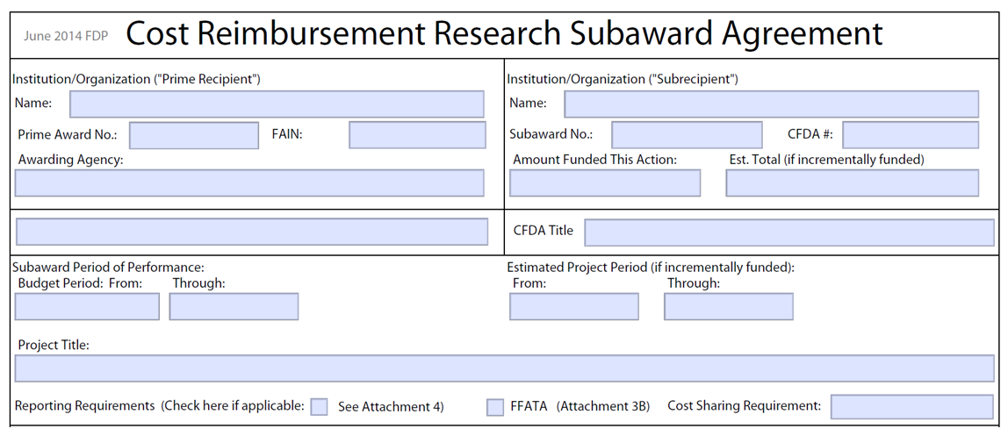

**22**

**21**

**20**

**19**

**17**

**18**

**16**

**15**

**14**

**5**

**4**

**6**

**13**

**12**

**11**

**10**

**7**

**9**

**8**

**3**

**2**

**1**

| **ENH** | **Ref** | **Update to Template Needed** |  |
| --- | --- | --- | --- |
|  | **1** | Header Updated Needed | Update from “Cost Reimbursement Research Subaward Agreement” to “**FDP Cost Reimbursement Research Subaward Agreement**” |
|  | **2** | Remove Section Label | Remove section label “Institution/Organization (“Prime Recipient”)” |
|  | **3** | Remove Section Label | Remove section label “Institution/Organization (“Subrecipient”)” |
|  | **4** | Field label update needed | Update label from “Name:” to “**Pass-through Entity (PTE):**” |
| 1 | **5** | Create New Field | Create the new field “**PTE Principal Investigator (PI):**” below the field “Pass-through Entity (PTE):” |
|  | **6** | Field label update needed | Update label from “Prime Award No.:” to “**PTE Federal Award No**” |
|  | **7** | Field label update needed | Update label from “Awarding Agency” to “**Federal Awarding Agency**” |
|  | **8** | Field label update needed | Update label from “Name” to “**Subrecipient**” |
| 2 | **9** | Create New Field | Create the new field “**Subrecipient Principal Investigator (PI):**” below the field “Subrecipient:” |
| 3 | **10** | Create New Field | Create the new field “**Federal Award Issue Date:**” below the field “Subrecipient:” |
| 4 | **11** | Create New Field | Create the new field “**Total Amount of Federal Award to PTE:**” to the right of the field “Federal Award Issue Date:” |
|  | **12** | Field label update needed | Update label from “CFDA #:” to “**CFDA No:**” |
|  | **13** | Field label update needed | Update label from “Budget Period: From” to “**Start:**” |
|  | **14** | Field label update needed | Update label from “Through:” to “**End:**” |
|  | **15** | Field label update needed | Update label from “From:” to “**Start:**” |
|  | **16** | Field label update needed | Update label from “Through:” to “**End:**” |
| 5 | **17** | Create New Field | Create the new field “**Incrementally Estimated Total:**” to the right of the field “End:” |
| 6 | **18** | Create New Field | Create the new field “**Is this Award R & D Yes or No**” to the right of the field “Incrementally Estimated Total:” |
|  | **19** | Field label update needed | Update label from “Reporting Requirements” to “**Check all that apply:**” |
|  | **20** | Field label update needed | Update checkbox label from “See Attachment 4” to “**Reporting Requirements (Attachment 4)**” |
|  | **21** | Field label update needed | Update checkbox label from “FFATA (Attachment 3B)” to “**Subject to FFATA (Attachment 3B)**” |
| 7 | **22** | Field label update needed | Update label from “Cost Sharing Requirement” to “**Cost Sharing (Attachment 5)**” and change field from text field to checkbox field |

The screen mockup below represents the new state FDP Cost Reimbursement Template.

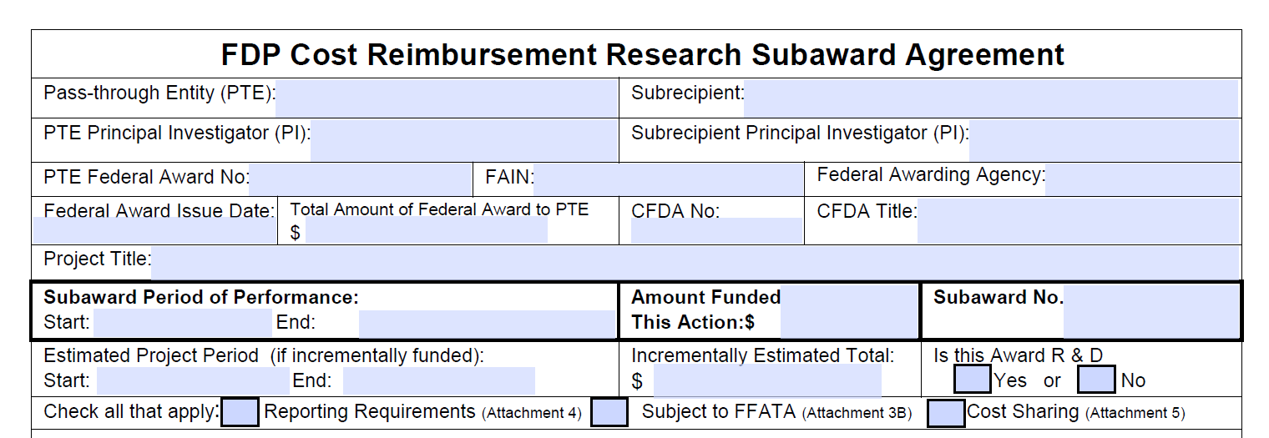

**22**

**21**

**20**

**19**

**18**

**17**

**16**

**15**

**13**

**14**

**12**

**11**

**10**

**7**

**6**

**9**

**8**

**5**

**4**

**1**

The screen mockup below represents the current state Cost Reimbursement Template Terms & Conditions. The fields that are numbered indicate changes to the Terms & Conditions section that will be present on the new FDP Cost Reimbursement Template Terms &Conditions section.

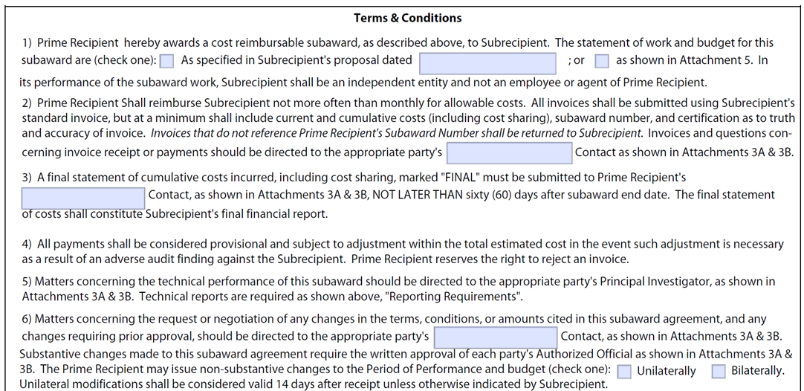

**7**

**6**

**5**

**4**

**3**

**2**

**1**

**8**

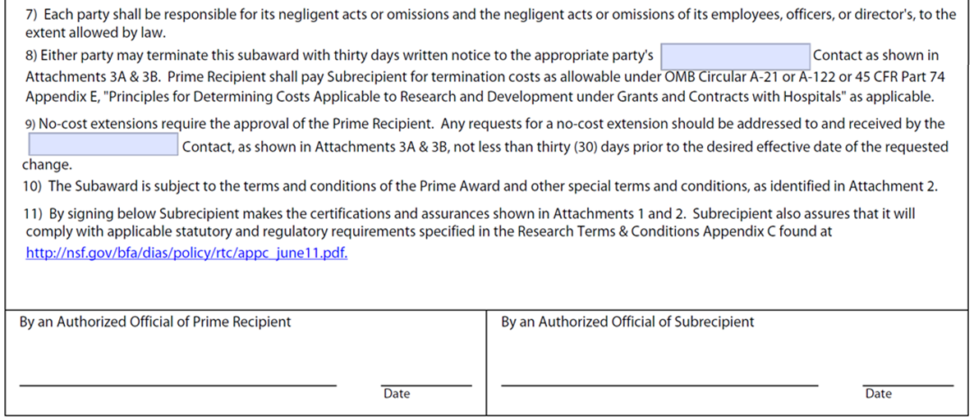

**19**

**18**

**17**

**16**

**15**

**14**

**13**

**12**

**11**

**10**

**9**

|  |  |  |  |
| --- | --- | --- | --- |
| **ENH** | **Ref** | **Update to Terms & Condition section** |  |
|  | **1** | Update to header label change | Change Terms & Conditions label to “Terms and Conditions” |
|  | **2** | Update to term and condition | The text for 1) should now display: “PTE hereby awards a cost reimbursable subaward, as described above, to Subrecipient. The statement of work and budget for this subaward are (check one) □ as specified in Subrecipient’s proposal dated or □as shown in Attachment 5. In its performance of subaward work, Subrecipient shall be an independent entity and not an employee or agent of PTE. |
|  | **3** | Update to term and condition | The text for 2) should now display: “PTE shall reimburse Subrecipient not more often than monthly for allowable costs. All invoices shall be submitted using Subrecipient’s standard invoice, but at a minimum shall include current and cumulative costs (including cost sharing), subaward number, and certification, as required in 2 CFR 200.415 (a). Invoices that do not reference PTE Subaward number shall be returned to Subrecipient. Invoices and questions concerning invoice receipt or payments should be directed to the appropriate party’s Contact, as shown in Attachments 3A.” |
|  | **4** | Update to term and condition | The text for 3) should now display: “A final statement of cumulative costs incurred, including cost sharing, marked "FINAL" must be submitted to PTE’s  Contact, as shown in Attachments 3A, NOT LATER THAN **60** days after subaward end date. The final statement of costs shall constitute Subrecipient's final financial report.” |
|  | **5** | Update to term and condition | The text for 4) should now display: “All payments shall be considered provisional and subject to adjustment within the total estimated cost in the event such adjustment is necessary as a result of an adverse audit finding against the Subrecipient. PTE reserves the right to reject an invoice, in accordance with 2 CFR 200.305.” |
|  | **6** | Update to term and condition | The text for 5) should now display: ‘Matters concerning the technical performance of this subaward should be directed to the appropriate party’s Principal Investigator as shown in Attachments 3A and 3B. Technical reports are required as shown above, “Reporting Requirements."’ |
|  | **7** | Update to term and condition | The text for 6) should now display: “Matters concerning the request or negotiation of any changes in the terms, conditions, or amounts cited in this subaward agreement, and any changes requiring prior approval, should be directed to the appropriate party’s Contact, as shown in Attachments 3A and 3B. Any such changes made to this subaward agreement require the written approval of each party's Authorized Official, as shown in Attachments 3A and 3B.” |
|  | **8** | New term and condition | The text for 7) represents a new term and condition as a result of splitting 6) and should now display: “Substantive changes made to this subaward agreement require the written approval of each party's Authorized Official as shown in Attachments 3A and 3B. The PTE may issue non-substantive changes to the Period of Performance (check one) □ Bilaterally, or □ Unilaterally. Unilateral modifications shall be considered valid 14 days after receipt unless otherwise indicated by Subrecipient.” |
|  | **9** | Update to term and condition | The text for 8) should now display: “Each party shall be responsible for its negligent acts or omissions and the negligent acts or omissions of its employees, officers, or directors, to the extent allowed by law.” |
|  | **10** | Update to term and condition | The text for 9) should now display: ‘Either party may terminate this subaward with thirty days written notice to the appropriate party’s Contact, as shown in Attachments 3A and 3B. PTE shall pay Subrecipient for termination costs as allowable under Uniform Guidance, 2 CFR 200, or 45 CFR Part 74 Appendix E, “Principles for Determining Costs Applicable to Research & Development under Grants and Contracts with Hospitals, as applicable”.’ |
|  | **11** | Update to term and condition | The text for 10) should now display: “No-cost extensions require the approval of the PTE. Any requests for a no-cost extension should be addressed to and received by the Contact, as shown in Attachments 3A, not less than 30 days prior to the desired effective date of the requested change.” |
|  | **12** | Update to term and condition | The text for 11) should now display: “The Subaward is subject to the terms and conditions of the PTE Award and other special terms and conditions, as identified in Attachment 2.” |
|  | **13** | Update to term and condition | The text for 12) should now display: “By signing this Research Subaward Agreement Subrecipient makes the certifications and assurances shown in Attachments 1 and 2.” |
|  | **14** | New term and condition | The text for 13) represents a new term and condition and should display: “Research Terms & Conditions – RESERVED.” |
|  | **15** | Update to label | Label change from Prime Recipient to “Pass-through Entity:” |
| 8 | **16** | Create new label | Create label name “Name”. |
| 9 | **17** | Create new label | Create label name “Title”. |
| 10 | **18** | Create new label | Create label name “Name”. |
| 11 | **19** | Create new label | Create label name “Title”. |

The screen mockup below represents the Terms and Conditions for the new state FDP Cost Reimbursement Template.

**1**

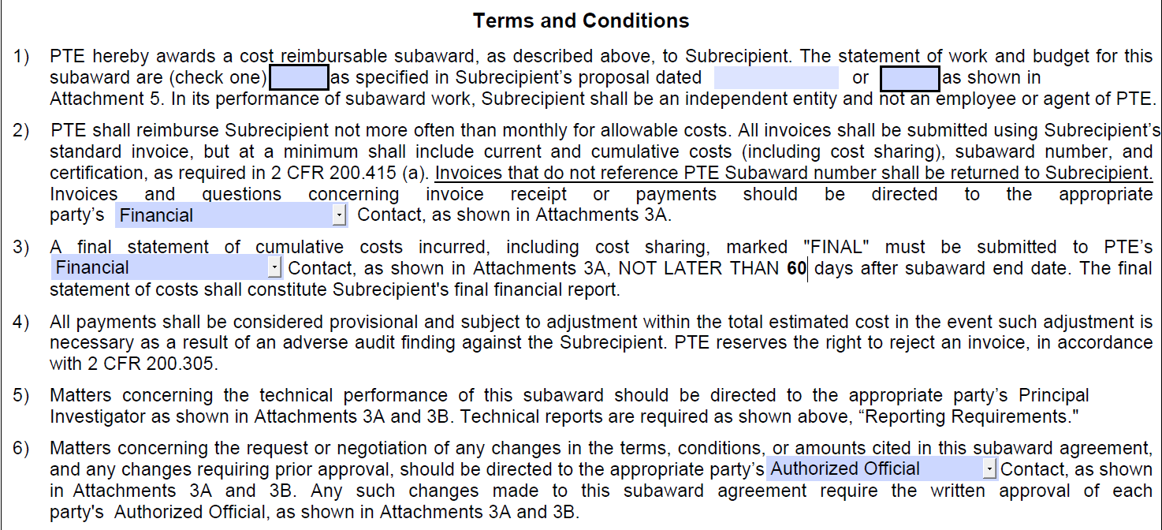

**7**

**6**

**5**

**4**

**3**

**2**

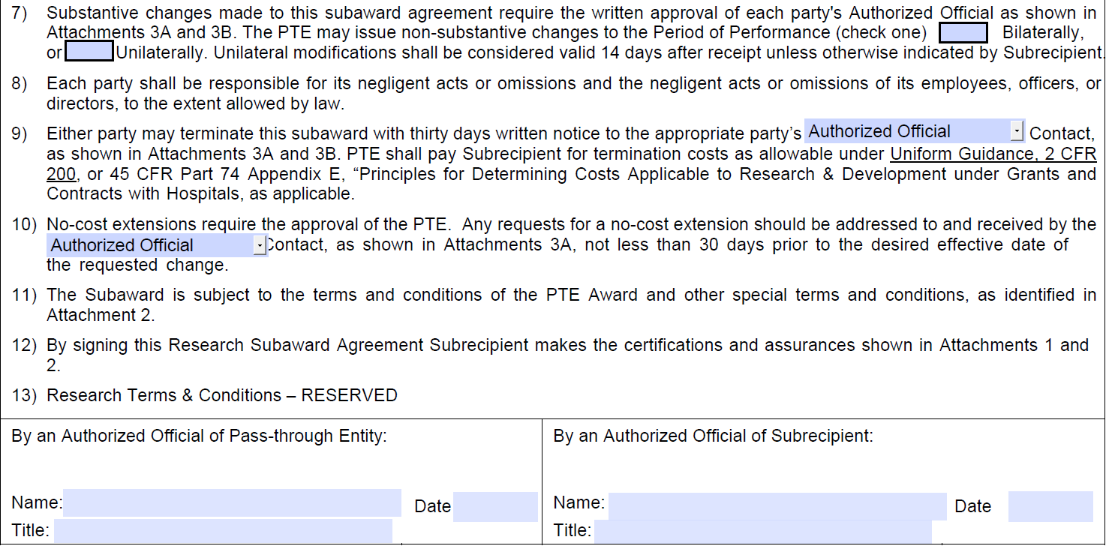

**19**

**18**

**17**

**16**

**15**

**14**

**13**

**12**

**11**

**10**

**9**

**8**

### FDP Template (Attachment 1)

The screen mockup below represents the current state Attachment 1 Template. The fields that are numbered indicate where changes in text on the new FDP Attachment 1 Template will be needed.

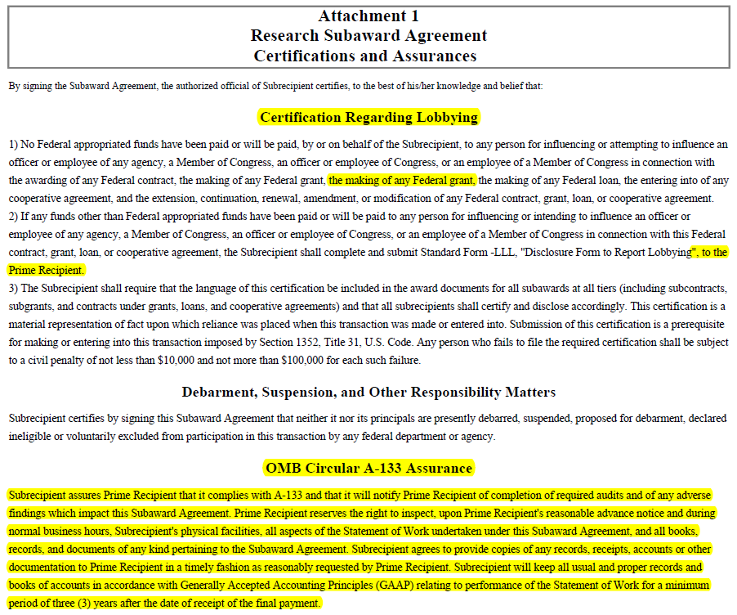

**7**

**6**

**2**

**5**

**4**

**3**

**1**

|  |  |  |  |
| --- | --- | --- | --- |
| **ENH** | **Ref** | **Update to Terms & Condition section** |  |
|  | **1** | Formatting change | **“Certification Regarding Lobbying”** should be left-justified. |
|  | **2** | Remove duplicate text | The following text is duplicated and should be removed: **“the making of any Federal grant,”** |
|  | **3** | Formatting change and text change. | The following text ‘ ”, to the Prime Recipient.’ should be changed to **‘,” to the Pass-through Entity.’** |
|  | **4** | Formatting change | New paragraph should begin at: “This certification is a ….” |
|  | **5** | Formatting change | **“Debarment, Suspension, and Other Responsibility Matters”** should be left-justified. |
|  | **6** | Replace text heading and formatting change | Replace OMB Circular A-133 Assurance with “Audit and Access to Records” and should be left-justified. |
|  | **7** | Replace paragraph text. | Replace text under OMB Circular A-133 Assurance section with new text from the “Audit and Access to Records” section:  “Subrecipient certifies by signing this Subaward Agreement that it complies with the Uniform Guidance, will provide notice of the completion of required audits and any adverse findings which impact this subaward as required by parts 200.501-200.521, and will provide access to records as required by parts 200.336, 200.337, and 200.201 as applicable.”. |

The screen mockup below represents the text and formatting changes made to Attachment 1 for the new state Attachment 1 Template.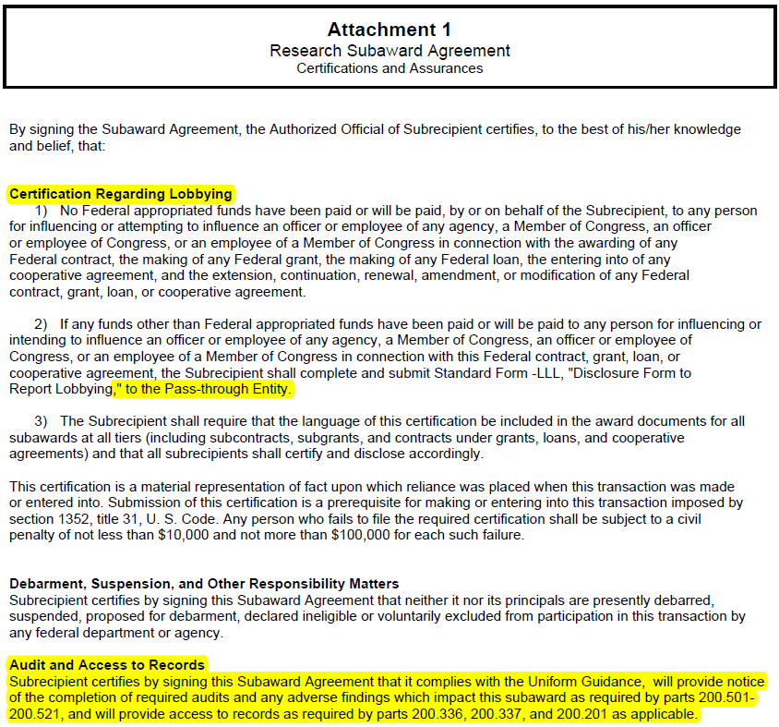

**6**

**1**

**7**

**5**

**4**

**3**

**2**

### FDP Template (3A)

The screen mockup below represents the current state Template for Attachment 3A. The fields that are numbered indicate text changes or insertion points to the new FDP Attachment 3A Template.

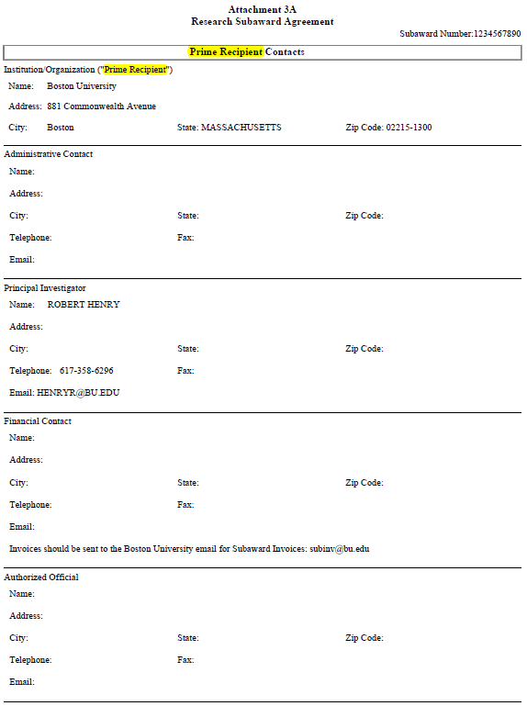

**6**

**3**

**4**

**5**

**2**

**1**

|  |  |  |  |
| --- | --- | --- | --- |
| **ENH** | **Ref** | **Update to Terms & Condition section** |  |
|  | **1** | Change header label | Replace “Prime Recipient” with **“Pass-through Entity”** |
|  | **2** | Change header label | Replace “Prime Recipient” with **“Pass-through Entity”** |
|  | **3** | Insert text before label | Insert **“Pass-through Entity’s”** before Administrative Contact |
|  | **4** | Insert text before label | Insert **“Pass-through Entity’s”** before Principal Investigator |
|  | **5** | Insert text before label | Insert **“Pass-through Entity’s”** before Financial Contact |
|  | **6** | Insert text before label | Insert **“Pass-through Entity’s”** before Authorized Official |

The screen mockup below represents the text changes made to Attachment 3A for the new state Attachment 3A Template.

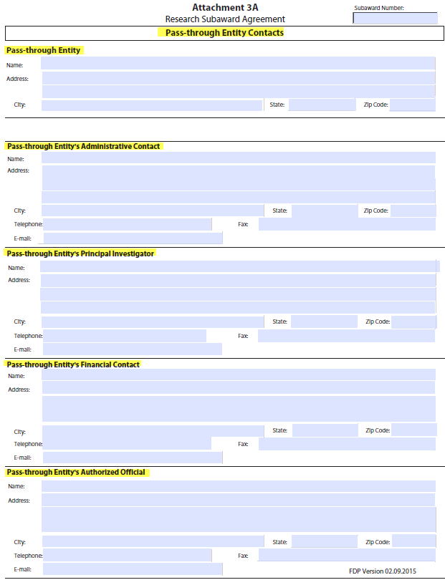

**1**

**2**

**3**

**4**

**6**

**5**

### FDP Template (Amendment)

The screen mockup below represents the current state Template for an Amendment. The fields that are numbered indicate text changes, deletions, or insertion points to the new FDP Amendment Template.

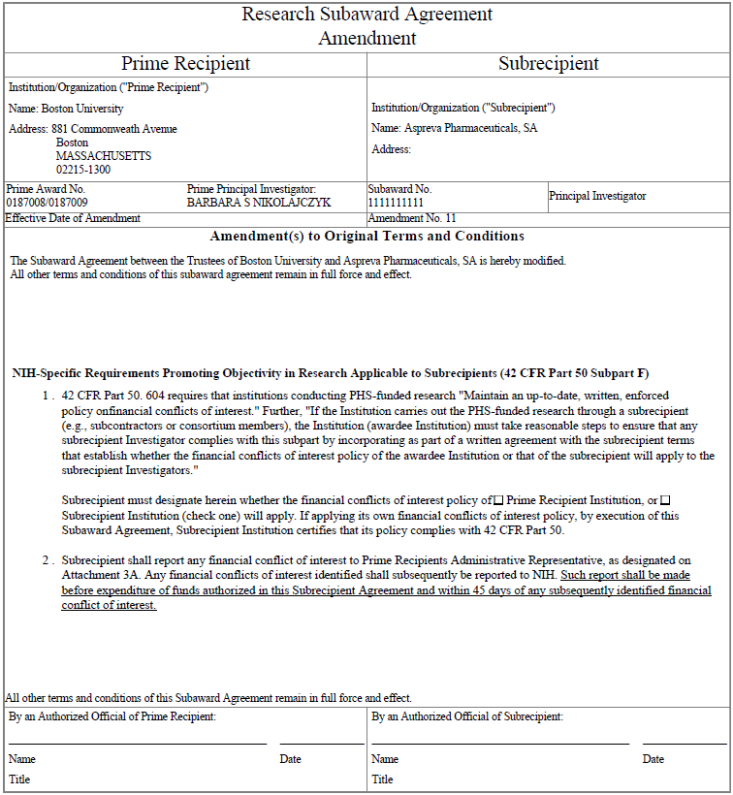

**17**

**18**

**16**

**15**

**19**

**20**

**14**

**13**

**12**

**10**

**11**

**6**

**4**

**5**

**2**

**7**

**9**

**3**

**8**

**3**

**1**

|  |  |  |  |
| --- | --- | --- | --- |
| **ENH** | **Ref** | **Update to Terms & Condition section** |  |
|  | **1** | Update to header label change | Update header label from “Prime Recipient” to **“Pass-through Entity (PTE):”**. |
|  | **2** | Remove header label | Remove “Institution/Organization: (“Prime Recipient”)” header. |
|  | **3** | Field label update needed | Update field label from “Name” to “**PTE**”. |
|  | **4** | Field label update needed | Update field label from “Prime Principal Investigator” to **“PTE Principal Investigator (PI:)”**. |
|  | **5** | Remove header label | Remove “Institution/Organization: (“Subrecipient”)” header. |
|  | **6** | Field label update needed | Update field label from “Name” to “**Subrecipient**”. |
|  | **7** | Field label update needed | Update field label from “Principal Investigator” to **“Subrecipient Principal Investigator (PI):”**. |
|  | **8** | Field label update needed | Update field label from “Prime Award No.” to **“PTE Federal Award No:”**. |
| 12 | **9** | Create New Field | Create new field called **“FAIN”**. |
| 13 | **10** | Create New Field | Create new field called “**Federal Awarding Agency**”. Note: field previously called “Awarding Agency” and is current being used on Cost Reimbursement template. |
| 14 | **11** | Create New Field | Create new field called **“Project Title”**. |
|  | **12** | Create New header label | Create new header label called **“Subaward Period of Performance”**. |
|  | **13** | Move field into header | Move **“Start Date:”** out of Terms and Conditions and into header. |
|  | **14** | Move field into header | Move **“End Date:”** out of Terms and Conditions and into header. |
| 15 | **15** | Create New Field | Create a new field called **“Amount Funded This Action:”.** |
| 16 | **16** | Create New Field | Create a new field called **“Total Amount of Federal Funds Obligated to date:”** |
| 17 | **17** | Create New Yes/No Field | Create a new field called **“Subject to FFATA”** |
|  | **18** | Create New sub-header label | Create a new sub-header label called **“This Amendment revises the above-referenced Research Subaward Agreement as follows:”** |
|  | **19** | Create New text label | Create new text label called **“Action”.** |
|  | **20** | Field label update needed | Update field label from “Prime Recipient:” to **“Pass-through Entity:”**. |

The screen mockup below represents the text changes made to the Amendment template for the new state Amendment Template.

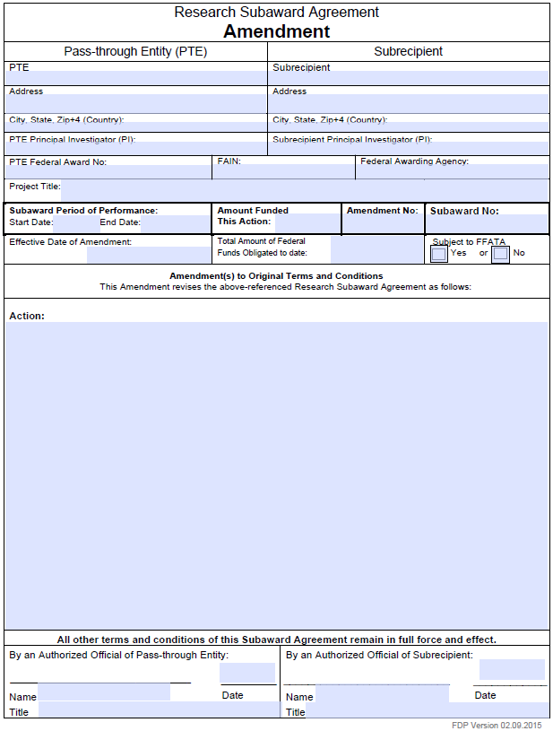

**11**

**10**

**6**

**3**

**20**

**19**

**18**

**17**

**16**

**12**

**15**

**14**

**13**

**9**

**8**

**7**

**4**

**5**

**2**

**1**

### Enhancements

|  |  |
| --- | --- |
| **Enhancement Number Reference** | **Customization Description** |
| 1 | The new field “**PTE Principal Investigator (PI):**” should have the name of the BU Award PI feed into the template field. |
| 2 | The new field “**Subrecipient Principal Investigator (PI):**” should have the name of the Site PI feed into the template field. |
| 3 | The new field “**Federal Award Issue Date:**” should have the date for the Federal Award Issue Date from Awards > Award > Details and Dates > **Notice Date** feed into the template field. |
| 4 | The new field “**Total Amount of Federal Award to PTE:**” should have the Total Obligated Amount from T&M feed into the template field. |
| 5 | The new field “**Incrementally Estimated Total:**” should have the Total Anticipated Amount from T&M feed into the template field. |
| 6 | The new field “**Is this Award R & D Yes or No**” will provide checkboxes will have to be selected manually. |
| 7 | The field “**Cost Sharing (Attachment 5)**” will change from a manually entered text field to a manually selected checkbox field. |
| 8 | The Pass-through Entity **“Name:”** field should have the name of the Prime Authorized Official from KC Subaward > Subaward > Contacts feed into the template field. |
| 9 | The Pass-through Entity **“Title:”** field should have the title of the Prime Authorized Official from KC Subaward > Subaward > Contacts feed into the template field. |
| 10 | The Subrecipient **“Name:”** field should have the name of the Subaward Authorized Official from KC Subaward > Subaward > Contacts feed into the template field. |
| 11 | The Subrecipient **“Title:”** field should have the title of the Subaward Authorized Official from KC Subaward > Subaward > Contacts feed into the template field. |
| 12 | Create new field called **“FAIN”** which will have the FAIN number from the parent KC Award, KC Awards > Award > Details and Dates > Sponsor > FAIN feed into the template field. |
| 13 | Create new field called “**Federal Awarding Agency**” which will have the Federal Awarding Agency (previously labeled as Awarding Agency), KC Subawards > Subaward > Funding Source > Sponsor ID, feed into the template field. |
| 14 | Create new field called **“Project Title”** which will feed the Project Title from KC Awards > Award > Details and Dates > Award Title into the template field. |
| 15 | Create a new field called **“Amount Funded This Action:”** which will feed the Obligated Amount from KC Subawards > Financial > History of Changes > Obligated Amount into the template field**.** |
| 16 | Create a new field called **“Total Amount of Federal Funds Obligated to date:”** which will feed the total obligated funds from T&M into the template field. |
| 17 | The new field called **“Subject to FFATA”** is a Yes/No field that should have either “Yes” or “No” feed into the “Subject to FFATA” template field from KC Subawards > Custom Data > General > FFATA Required (Y/N)”. If a “P” is entered then neither Yes or No should be fed into the field. |